Identifying Optimal Oblong Collar Positions through a Novel Performance Index to Mitigate Azimuthal Scour Around Oblong Bridge Piers

Supplementary information: -

Tania Sultana¹, and Subhasish Das^{2*}
¹Doctoral Research Fellow, School of Water Resources Engineering, Jadavpur University, Kolkata 700032, West Bengal, India, Email- tanias.swre.rs@jadavpuruniversity.in, ORCID- 0009-0000-9564-0008

²Associate professor and Joint Director, School of Water Resources Engineering, Jadavpur University, Kolkata 700032, West Bengal, India, Email- subhasish.das@jadavpuruniversity.in, ORCID- 0000-0002-6512-7454 (*Corresponding author)

Additional Literature Review

Pier scour remains a major cause of structural failure, accounting for about 60% of bridge collapses in the United States (Lagasse et al. 2007). Das et al. (2014) found that equilibrium scour depth, length, width, area, and volume depend on the effective pier width. Previous studies indicate that combining collars with other countermeasures, such as riprap and cables, enhances scour protection compared with using collars alone (Nohani et al. 2012; Abbasi et al. 2023). Their size and vertical position strongly influence the effectiveness of collars. Pandey et al. (2020) reported that scour reduction increases with collar width (B_{c}) but decreases as collar elevation (E_{c}) rises above the bed. Similarly, Raeisi and Ghomeshi (2022) found that collars placed at the bed surface are more effective, whereas deeply buried collars are less effective (Jahangirzadeh et al. 2014). Khodashenas et al. (2018) showed that square collars outperform circular ones in reducing scour. Qi et al. (2021) observed that collars divide the vortex system into two parts by restricting the horseshoe vortex beneath the collar and away from the bed, thereby reducing its erosive effect. Valela et al. (2021) observed that maximum scour shifts toward the side of the collar due to flow acceleration around collar edges. Larger collars also allow more effective distribution of flow energy in the upstream area and therefore suppress vortex formation (Affandy et al. 2025). For piers with collars, equilibrium was considered to be reached when the scour depth changed by less than 1 mm over a 6 h period (Chen et al. 2018). Recent studies have further advanced understanding of flow dynamics and scour evolution, including turbulent flow characterization around oblong piers (Bento et al. 2021). Nandi and Das (2023) proposed a temporal scour depth prediction formula for circular piers based on 57 years of laboratory datasets. Double collar systems have been shown to significantly reduce scour depth, although their effectiveness reduces under higher flow intensities (Mashahir et al. 2024).

Bibliography

Abbasi, S., S. Ravaz, M. Heidarpour, R. Daneshfaraz, and J. Abraham. 2023. “Investigating and comparing the performance of collar and cable composition on scouring of cylindrical bridge piers.” Sādhanā 48 (Aug): 149. https://doi.org/10.1007/s12046-023-02186-0
Affandy, E., M. S. Pallu, F. Maricar, and B. Bakri. 2025. “An Experimental Study on Local Scour Protection for Round Slotted Bridge Piers with Collar Variations.” Eng. Appl. Sci. Technol. 15 (6): 29685–29695. https://doi.org/10.48084/etasr.14582
Bento, A. M., T. Viseu, J. P. Pêgo, and L. Couto. 2021. “Experimental characterization of the flow field around oblong bridge piers.” Fluids 6 (11): 370. https://doi.org/10.3390/fluids6110370
Chen, S. C., S. Tfwala, T. Y. Wu, H. C. Chan, and H. T. Chou. 2018. “A hooked-collar for bridge piers protection: Flow fields and scour.” Water 10 (9): 1251. https://doi.org/10.3390/w10091251
Das, S., R. Das, and A. Mazumdar. 2014. “Vorticity and Circulation of Horseshoe Vortex in Equilibrium Scour Holes at Different Piers.” J. Inst. Eng. India Ser. A 95 (Jun): 109–115. https://doi.org/10.1007/s40030-014-0078-7
Jahangirzadeh, A., H. Basser, S. Akib, H. Karami, S. Naji, and S. Shamshirband. 2014. “Experimental and numerical investigation of the effect of different shapes of collars on the reduction of scour around a single bridge pier.” PLoS One 9 (6): e98592. https://doi.org/10.1371/journal.pone.0098592
Lagasse, P. F., P. E. Clopper, L. W. Zevenbergen, and L. G. Girard. 2007. Countermeasures to Protect Bridge Piers from Scour. NCHRP Report 593, Transportation Research Board, US: Washington, DC.
Mashahir, M., A. R. Zarrati, and M. Karimaei Tabarestani. 2024. “Evaluation of collar efficiency to prevent scouring around cylindrical bridge piers under live bed condition.” J. Hydro-Environ. Res. 52 (Jan), 17–25. https://doi.org/10.1016/j.jher.2023.12.001
Nandi, B., and S. Das. 2023. “Identify most promising temporal scour depth formula for circular piers proposed over last six decades.” Ocean Eng. 286 (Oct): 115639. https://doi.org/10.1016/j.oceaneng.2023.115639
Nohani, E., M. Shafai Bejestan, A. Masjedi, and H. A. Kashkuli. 2012. “Riprap stability in the vicinity of a bridge pier fitted with a collar in the river bend.” World Appl. Sci. J. 20 (3): 354–358.
Pandey, M., J. H. Pu, H. Pourshahbaz, and M. A. Khan. 2022. “Reduction of scour around circular piers using collars.” J. Flood Risk Manag. 15 (3): e12812. https://doi.org/10.1111/jfr3.12812
Qi, H., W. Tian, and H. Zhang. 2021. “Modeling Local Scour around a Cylindrical Pier with Circular Collar with Tilt Angles (Counterclockwise around the Direction of the Channel Cross-Section) in Clear-Water.” Water 13 (22): 3281. https://doi.org/10.3390/w13223281
Raeisi, N., and M. Ghomeshi. 2022. “A laboratory study of the effect of asymmetric-lattice collar shape and placement on scour depth and flow pattern around a bridge pier.” Water Supply 22 (1): 734–746748. https://doi.org/10.2166/ws.2021.239
Valela, C. 2021. “Reduction of bridge pier scour through the use of a novel collar design.” PhD Thesis, University of Ottawa, Ottawa, ON, Canada.

Evidence of fully developed flow

In the present experiments, the pier was located 5.5 m downstream of the flume inlet. Fully developed flow occurs when the boundary layer expands across the entire flow depth, creating a stable velocity profile with no further changes in the velocity gradient. To verify this, the boundary layer thickness (δ) was calculated using Schlichting’s (1979) equation, $δ=0.37x{\left(\frac{Ux }{\text{ν}}\right)}^{{-1}/5}$ , where x is the distance from the flume inlet. The calculated δ values are greater than the flow depth (h) in all tests, confirming that fully developed flow was achieved.
Similarly, Laha et al. (2026) applied Schlichting’s boundary layer equation to verify fully developed flow and obtained δ = 0.116 m. Harshvardhan and Kaushal (2025) also positioned the pier 5.55 m downstream of the inlet, where the calculated δ was 0.12 m, indicating that the flow was fully developed. The boundary layer calculations in our experiments are provided in Table S1.

Table S1. Boundary layer thickness calculation using Schlichting’s equation.

Q | h | U | x | δ | Full development
(cumec) | (m) | (m/s) | (m) | (m) | If δ > h, True, else false
0.0255 | 0.115 | 0.273 | 5.5 | 0.118 | True

References
Harshvardhan, and D. R. Kaushal. 2025. “Experimental study on the equilibrium scour pattern around isolated piers of varying diameter and inflow velocity.” Part. Sci. Technol. 43 (5): 805–819. https://doi.org/10.1080/02726351.2025.2494042.
Laha, S., B. Nandi, and S. Das. 2026. “Identification of safe distance between eccentric bridge piers to minimize scour by considering mutual interference and morphology.” J. Irrig. Drain. Eng. 152 (4): 04026013. https://doi.org/10.1061/JIDEDH.IRENG-10656.
Schlichting, H., and K. Gersten. 1979. Boundary-layer theory. 7th ed. Translated by J. Kestin. New York: McGraw-Hill.

Table S2. Sources of uncertainty in the experimental variables and methods used to minimize their effects.

Category | Variable | Causes of uncertainty | Strategies to minimize
Observational uncertainty | Discharge (Q) | Instrumental accuracy and precision, and pump motor voltage fluctuation | Calibrated flow meter used (±2% of reading), steady-state conditions established before measurement, Q held constant across all 45 tests.
 | Flow depth (h) | Water-surface fluctuations and reading and recording errors. | Depth controlled via the tailgate.
 | Maximum scour depth (d_{sm}) | Laser distometer resolution (±1.5 mm) and alignment. | Dry-bed profiling after carefully draining the water.
 | Collar geometry (collar width, collar position) | Fabrication tolerance, error in setting the collar elevation (E_{c}) relative to the sediment bed. | Precision-fabricated collars: measure collar width (B_{c}) with scales and check bed-level reference before each experimental run.
 | Azimuth angle location (θ = 0°, 32°, 90°, 148°, 180°) | Manual positioning of the measurement point may shift the recorded d_{sm} location. | Pre-marked angular reference points were used for repeatable positioning around the collar.
Parametric uncertainty | Sediment characteristics (d₅₀, σ_{g}) | Natural non-uniformity of bed material. | The same sediment (σ_{g} = 1.68) was used in all tests, keeping bed-material properties constant.
 | Velocity (U) | Derived as discharge/area, where area depends on measured flume width and water depth. | Constant velocity was maintained, and the flume width was measured precisely.
Structural uncertainty | Flume geometry and boundary effects | The finite flume width (B_{f} = 0.81 m) may influence the flow field and scour around the pier. Inlet disturbances may also affect flow development. | The pier width (B) was 7 cm to avoid sidewall effects. Pier was placed 5.5 m from the inlet to establish fully developed flow before reaching the test section.

Table S3. Quantitative uncertainty of the experimental parameters.

Parameter | Source of uncertainty | Standard uncertainty, u | Expanded uncertainty, U
Discharge, Q | Flow meter, ±2% of reading | 1.15% | ±2.3%
Flow depth, h | Scale reading error, ±1 mm | 0.58 mm | ±1.2 mm
Maximum scour depth, d_{sm} | Laser distance meter, ±1.5 mm | 0.87 mm | ±1.7 mm
Velocity, U | From Q, h and B_{f} (±1 mm) | 1.26% | ±2.5%
Froude number, Fr | From U and h | 1.38% | ±2.8%

Table S4. Hydraulic conditions and scour-reduction efficiencies in previous studies.

Literature | B_{c}/B | E_{c}/B | U/U_{c} | h/B | Fr | d₅₀/B | RE (%)
Zarrati et al. (2004) | 2.0–3.0 | 0.4, 0, -0.4, -0.8 | 0.90 | 3.9 | - | 0.02 | 10–74
Masjedi et al. (2010) | 1.5–3.0 | 0, -0.1, -0.5, -1 | 0.89 | 2.0 | 0.41 | 0.03 | 34–92
Heidarnejad et al. (2010) | 1.5–3.0 | 0, -0.1, -0.5, -1 | 0.93 | 2.0 | - | 0.02 | 19–76
Taheri and Ghomeshi (2019) | 3.0 | 1, 0.5, 0, -0.12 | 0.91 | 5.2 | 0.19 | 0.02 | 23–100
Moghanloo et al. (2022) | 4.0 | 0.2, 0.4, 0, -0.4, -0.8 | 0.98 | 3.6 | - | 0.03 | 23–61
Sultana et al. (2026b) | 1.5–3.5 | 0 | 0.84 | 1.64 | 0.26 | 0.01 | 34–58

Table S5. Pairwise comparison matrix used to derive the AHP weights.

Criterion | d_{sm}/B | B_{c}/B | V_{sm}/B³ | A_{sm}/B²
d_{sm}/B | 1 | 2 | 2 | 4
B_{c}/B | 1/2 | 1 | 2 | 3
V_{sm}/B³ | 1/2 | 1/2 | 1 | 2
A_{sm}/B² | 1/4 | 1/3 | 1/2 | 1

Table S6. Comparison of criteria weights obtained from the performance index, AHP, and CRITIC methods.

Parameter | Performance index (present study) | AHP weight | CRITIC weight
d_{sm}/B | 0.40 | 0.43 | 0.29
B_{c}/B | 0.30 | 0.29 | 0.36
V_{sm}/B³ | 0.20 | 0.18 | 0.18
A_{sm}/B² | 0.10 | 0.10 | 0.17
Sum | 1.00 | 1.00 | 1.00

Table S7. Mean, peak, and mean-to-peak ratio of d_{sm}/B for each collar width (B_{c}/B).

B_{c}/B | Mean d_{sm}/B | Peak d_{sm}/B | Mean/Peak
1.5 | 2.80 | 3.19 | 0.88
2 | 1.57 | 2.42 | 0.64
2.5 | 2.45 | 2.96 | 0.82
3 | 2.49 | 2.87 | 0.87
3.5 | 2.44 | 3.14 | 0.78

Table S8. Mean, peak, and mean-to-peak ratio of PI for each collar position (E_{c}/B).

E_{c}/B | Mean PI | Peak PI | Mean/Peak
-0.20 | 0.46 | 0.74 | 0.61
-0.175 | 0.52 | 0.80 | 0.65
-0.15 | 0.67 | 0.88 | 0.76
-0.125 | 0.55 | 0.95 | 0.58
-0.1 | 0.43 | 0.83 | 0.51
-0.05 | 0.41 | 0.77 | 0.53
0 | 0.50 | 0.84 | 0.60
0.05 | 0.50 | 0.68 | 0.73
0.15 | 0.34 | 0.75 | 0.45

Table S9. Performance score of scour reduction for various combinations of E_{c}/B and B_{c}/B using equal parameter weights (0.25, 0.25, 0.25, 0.25).

E_{c}/B | B_{c}/B | Score | B_{c}/B | Score | B_{c}/B | Score | B_{c}/B | Score | B_{c}/B | Score | Avg.
0.15 | 3.5 | 0.13 | 3.0 | 0.15 | 2.5 | 0.28 | 2.0 | 0.75 | 1.5 | 0.37 | 0.34
0.05 | 3.5 | 0.61 | 3.0 | 0.15 | 2.5 | 0.39 | 2.0 | 0.65 | 1.5 | 0.70 | 0.50
0 | 3.5 | 0.30 | 3.0 | 0.35 | 2.5 | 0.56 | 2.0 | 0.83 | 1.5 | 0.49 | 0.51
-0.05 | 3.5 | 0.20 | 3.0 | 0.22 | 2.5 | 0.40 | 2.0 | 0.76 | 1.5 | 0.42 | 0.40
-0.1 | 3.5 | 0.19 | 3.0 | 0.13 | 2.5 | 0.38 | 2.0 | 0.84 | 1.5 | 0.70 | 0.45
-0.125 | 3.5 | 0.44 | 3.0 | 0.24 | 2.5 | 0.57 | 2.0 | 0.92 | 1.5 | 0.72 | 0.58
-0.15 | 3.5 | 0.52 | 3.0 | 0.51 | 2.5 | 0.68 | 2.0 | 0.87 | 1.5 | 0.86 | 0.69
-0.175 | 3.5 | 0.49 | 3.0 | 0.41 | 2.5 | 0.35 | 2.0 | 0.79 | 1.5 | 0.71 | 0.55
-0.2 | 3.5 | 0.35 | 3.0 | 0.31 | 2.5 | 0.37 | 2.0 | 0.75 | 1.5 | 0.60 | 0.48

Table S10. Performance score of scour reduction under various combinations of E_{c}/B and B_{c}/B using parameter weights of I_{d} = 0.50, I_{B} = 0.25, I_{V} = 0.15, I_{A} = 0.10.

E_{c}/B | B_{c}/B | Score | B_{c}/B | Score | B_{c}/B | Score | B_{c}/B | Score | B_{c}/B | Score | Avg.
0.15 | 3.5 | 0.12 | 3.0 | 0.19 | 2.5 | 0.26 | 2.0 | 0.70 | 1.5 | 0.30 | 0.31
0.05 | 3.5 | 0.69 | 3.0 | 0.22 | 2.5 | 0.39 | 2.0 | 0.63 | 1.5 | 0.58 | 0.50
0 | 3.5 | 0.29 | 3.0 | 0.44 | 2.5 | 0.60 | 2.0 | 0.80 | 1.5 | 0.37 | 0.49
-0.05 | 3.5 | 0.22 | 3.0 | 0.27 | 2.5 | 0.43 | 2.0 | 0.72 | 1.5 | 0.32 | 0.39
-0.1 | 3.5 | 0.11 | 3.0 | 0.17 | 2.5 | 0.36 | 2.0 | 0.79 | 1.5 | 0.55 | 0.40
-0.125 | 3.5 | 0.41 | 3.0 | 0.28 | 2.5 | 0.60 | 2.0 | 0.96 | 1.5 | 0.53 | 0.56
-0.15 | 3.5 | 0.54 | 3.0 | 0.56 | 2.5 | 0.73 | 2.0 | 0.87 | 1.5 | 0.79 | 0.70
-0.175 | 3.5 | 0.48 | 3.0 | 0.44 | 2.5 | 0.33 | 2.0 | 0.75 | 1.5 | 0.53 | 0.51
-0.2 | 3.5 | 0.34 | 3.0 | 0.36 | 2.5 | 0.36 | 2.0 | 0.68 | 1.5 | 0.44 | 0.44

Table S11. Performance score of scour reduction under various combinations of E_{c}/B and B_{c}/B using parameter weights of I_{d} = 0.35, I_{B} = 0.35, I_{V} = 0.15, I_{A} = 0.15.

E_{c}/B | B_{c}/B | Score | B_{c}/B | Score | B_{c}/B | Score | B_{c}/B | Score | B_{c}/B | Score | Avg.
0.15 | 3.5 | 0.11 | 3.0 | 0.18 | 2.5 | 0.30 | 2.0 | 0.75 | 1.5 | 0.37 | 0.34
0.05 | 3.5 | 0.57 | 3.0 | 0.20 | 2.5 | 0.41 | 2.0 | 0.68 | 1.5 | 0.64 | 0.50
0 | 3.5 | 0.25 | 3.0 | 0.38 | 2.5 | 0.58 | 2.0 | 0.84 | 1.5 | 0.46 | 0.49
-0.05 | 3.5 | 0.18 | 3.0 | 0.25 | 2.5 | 0.43 | 2.0 | 0.77 | 1.5 | 0.40 | 0.41
-0.1 | 3.5 | 0.12 | 3.0 | 0.16 | 2.5 | 0.38 | 2.0 | 0.83 | 1.5 | 0.63 | 0.43
-0.125 | 3.5 | 0.36 | 3.0 | 0.26 | 2.5 | 0.58 | 2.0 | 0.95 | 1.5 | 0.62 | 0.55
-0.15 | 3.5 | 0.46 | 3.0 | 0.50 | 2.5 | 0.68 | 2.0 | 0.88 | 1.5 | 0.81 | 0.67
-0.175 | 3.5 | 0.41 | 3.0 | 0.41 | 2.5 | 0.36 | 2.0 | 0.80 | 1.5 | 0.62 | 0.52
-0.2 | 3.5 | 0.29 | 3.0 | 0.33 | 2.5 | 0.38 | 2.0 | 0.74 | 1.5 | 0.54 | 0.46

Table S12. The six alternative weighting schemes.

Scheme | Description | d_{sm}/B | B_{c}/B | V_{sm}/B³ | A_{sm}/B²
W1 | present study | 0.40 | 0.30 | 0.20 | 0.10
W2 | Equal weights | 0.25 | 0.25 | 0.25 | 0.25
W3 | Scour depth dominant | 0.50 | 0.25 | 0.15 | 0.10
W4 | Scour depth and collar width equal | 0.35 | 0.35 | 0.15 | 0.15
W5 | Analytic hierarchy process | 0.43 | 0.29 | 0.18 | 0.10
W6 | CRITIC method | 0.29 | 0.36 | 0.18 | 0.17

Table S13. Mean performance score and corresponding rank for each collar elevation under six weighting schemes.

E_{c}/B | W1 | W2 | W3 | W4 | W5 | W6 | Mean | SD | Rank
 | Average Score of all B_{c}/B |  |  |  |  |  |  |  | W1 | W2 | W3 | W4 | W5 | W6
0.15 | 0.34 | 0.34 | 0.31 | 0.34 | 0.33 | 0.35 | 0.34 | 0.01 | 1 | 1 | 1 | 1 | 1 | 1
0.05 | 0.51 | 0.50 | 0.50 | 0.50 | 0.51 | 0.49 | 0.50 | 0.01 | 6 | 5 | 6 | 6 | 6 | 5
0 | 0.50 | 0.51 | 0.49 | 0.49 | 0.50 | 0.50 | 0.49 | 0.01 | 5 | 6 | 5 | 5 | 5 | 6
-0.05 | 0.41 | 0.40 | 0.39 | 0.41 | 0.40 | 0.41 | 0.40 | 0.01 | 2 | 2 | 2 | 2 | 2 | 2
-0.10 | 0.42 | 0.45 | 0.40 | 0.43 | 0.41 | 0.44 | 0.42 | 0.02 | 3 | 3 | 3 | 3 | 3 | 3
-0.125 | 0.56 | 0.58 | 0.56 | 0.55 | 0.56 | 0.56 | 0.56 | 0.01 | 8 | 8 | 8 | 8 | 8 | 8
-0.15 | 0.68 | 0.69 | 0.70 | 0.67 | 0.69 | 0.66 | 0.68 | 0.01 | 9 | 9 | 9 | 9 | 9 | 9
-0.175 | 0.52 | 0.55 | 0.51 | 0.52 | 0.52 | 0.53 | 0.52 | 0.01 | 7 | 7 | 7 | 7 | 7 | 7
-0.20 | 0.46 | 0.48 | 0.44 | 0.46 | 0.45 | 0.47 | 0.46 | 0.01 | 4 | 4 | 4 | 4 | 4 | 4

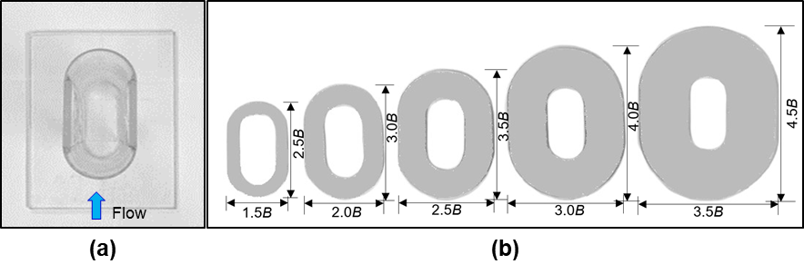
Fig. S1. (a) Designed geometry of oblong pier; (b) collars of varying B_{c} used for experiments (not to scale).

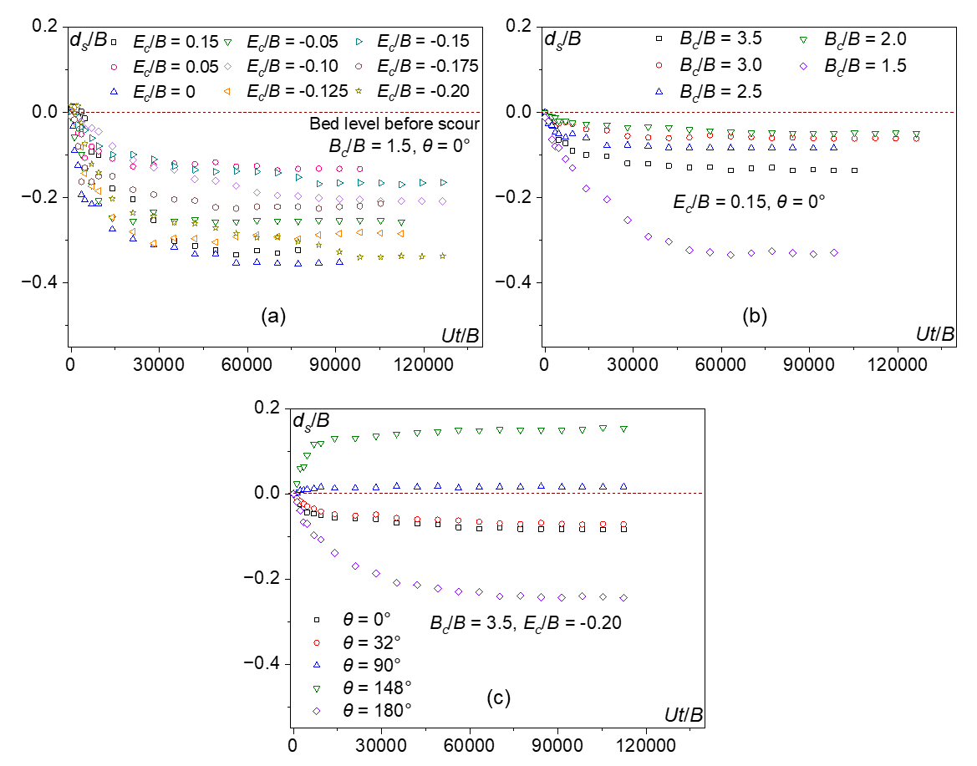

Fig. S2. Variation of d_{s}/B with Ut/B: (a) E_{c}/B = 0.15 to -0.20 for B_{c}/B = 1.5 at θ = 0°; (b) B_{c}/B from 1.5 to 3.5, with the collar at E_{c}/B = 0.15 at θ = 0°; and (c) θ = 0° to 180° for B_{c}/B = 3.5 with E_{c}/B = -0.20.

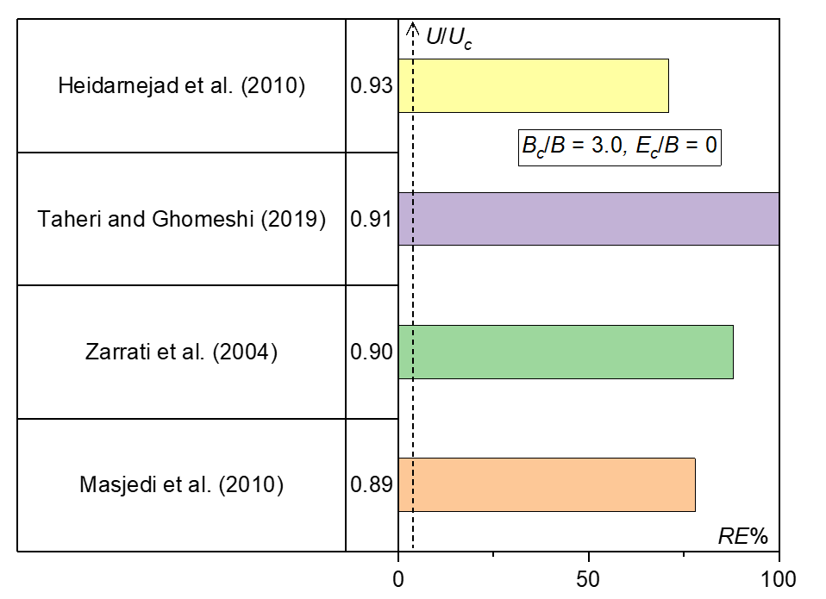
Fig. S3. Comparison of RE% for an identical collar geometry (B_{c}/B = 3.0 and E_{c}/B = 0) under different U/U_{c} based on existing literature.

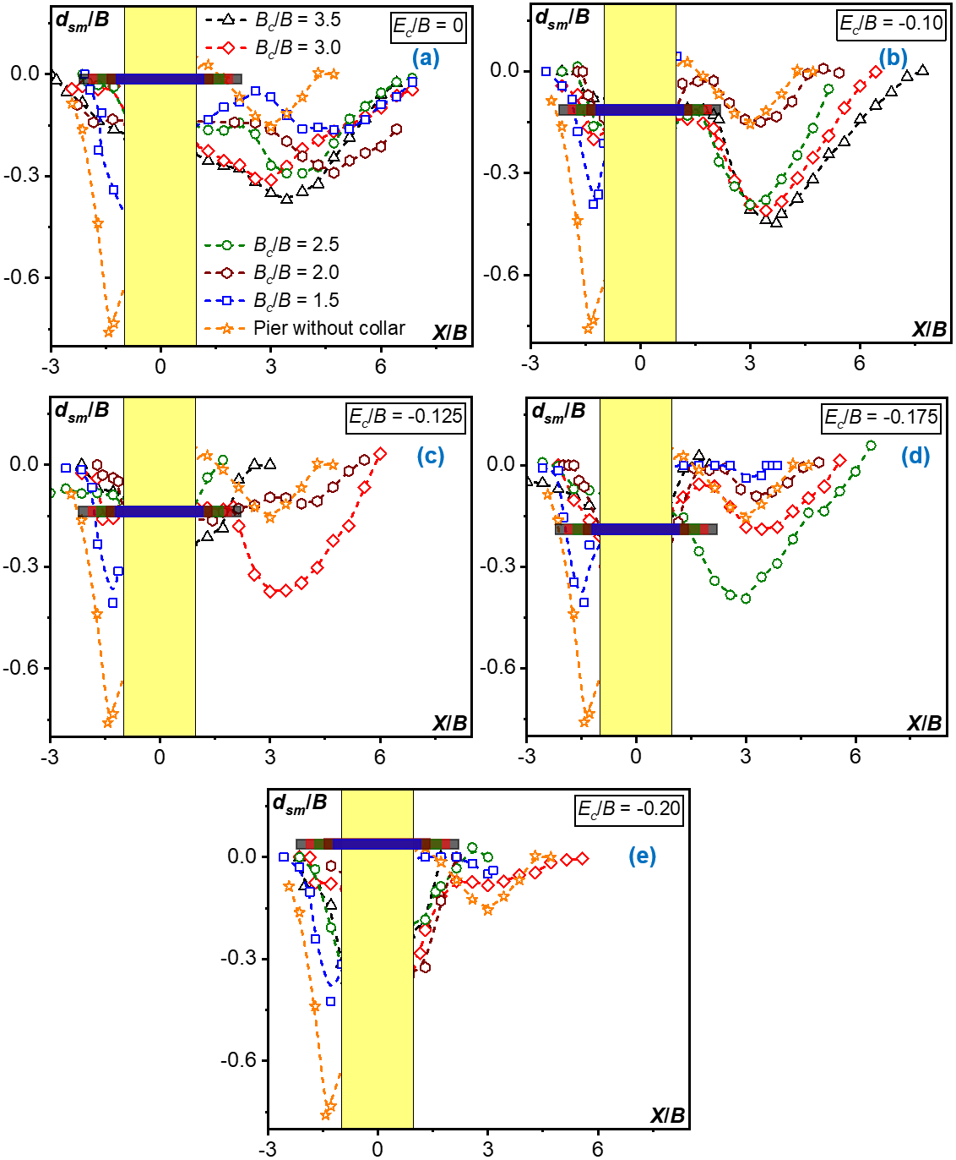
Fig. S4. Longitudinal profiles (X/B) of d_{sm}/B for different B_{c}/B: (a) E_{c}​/B = 0, (b) -0.10, (c) -0.125, (d) -0.175, and (e) -0.20. The yellow-shaded area represents the pier for L/B = 2.

